Educating Alberta’s Innovation Markets

A proposal prepared by the Alberta Council of Technologies Society for Alberta Innovates for establishing the means, the reach and the messages for educating Alberta’s innovation markets about Alberta enterprise, innovation and innovators. – October 30th, 2016
  - “Waking up the neighbours”

BACKGROUND
Alberta's economic profile is dominated by stories of oil and gas, natural resources, and government. Alberta enterprise, innovation, and innovators lack exposure both within the Province and elsewhere. Other significant contributors to Alberta enterprise and diversification of the economy are overwhelmed attention given to primary industries.

Awareness is essential for innovation. For those with an interest in innovation – the commercialization of emerging technologies, the lack of awareness may be contributing to the sentiment that Alberta's economic resilience is weak and it's innovation ecosystem is ineffective. Marketing of Alberta’s enterprising culture is lacking, and not the forte of government or in the interest of Alberta’s primary industries.

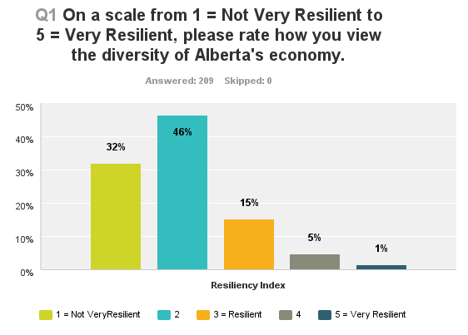 | 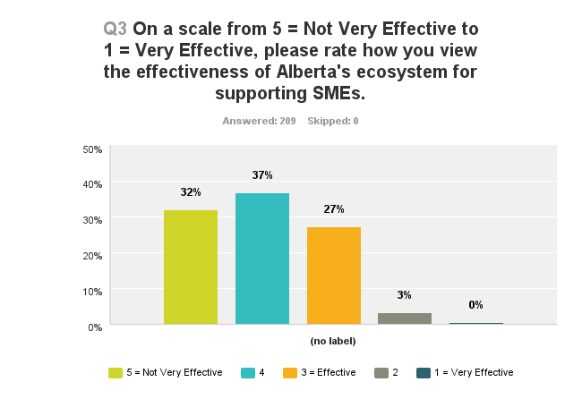
Awareness of Alberta enterprise is essential for development and extension of Alberta's underperforming innovation ecosystem:
- Formation of private capital - domestic and foreign, an essential element for innovation
- Investment in emerging technologies - creation of jobs and career opportunities
- Attracting students in science, technology, engineering, arts and mathematics (STEAM)
- Lessons learned by Alberta innovators – essential for small businesses survival, growth, and retention.

The following proposal aims to increase public awareness of Alberta enterprise both domestically and in Alberta’s other markets, markets prime for the exchange of knowledge and innovations. An associated objective is to increase the awareness and confidence in Alberta’s innovation system, essential for those working their way through the system.

Understanding the market. The Alberta Council of Technologies Society (ABCtech – Appendix A.) adopted "Innovation & Enterprise - The People. The Passion" as it's theme for 2013. The objective was to establish a vehicle for public education about Alberta innovation and enterprise. Since then, ABCtech has:

- Established ABCtech Media Productions – Appendix B, for development of The Next Question, a program of featuring interviews of Alberta innovators that include: two-minute audio episodes about Alberta innovations and innovators in: energy, transportation, health and creativity. These episodes were the product of a pilot launched in 2013. The archive also contains hours of interviews assembled during ABCtech’s Conferences and through our partner Hybrid Ventures. Also conducted a market analysis of the US public broadcasting market to assess it’s interest in The Next Question.

- Hosted several events contributing additional media content: E.g. Creativity & Convergence - 2015; Analytics, Big Data, and The Cloud – 2014. Preparing to assemble additional content through interviews of select participants at our November 26th, 2016 Convention “Creating the new Alberta – Vision & Leadership” – Appendix F.

- Increased the number of followers of ABCtech to 13,000 sharing a common interest in the commercialization of emerging technologies. This following is a significant contributor to ABCtech’s capability to conduct insightful surveys, events and identify sources of Alberta innovations and innovators – See Appendix A. ABCtech 2016 Brochure and G. Alberta’s Economic Resilience Survey Reports

- Conducted a pan-Alberta study of “Why SME’s fail to Grow” and an international assessment of the status of alternative energies extending ABCtech’s reach across Alberta and internationally. See Appendix H.

- Recognized the contributions to Alberta innovation of others through it's annual Innovation Award, granted in 2015 to the profession of engineers and pending for Alberta Youth at our Convention November 26th, 2016.

- Formed partnerships for extending it's broadcasting reach: across Alberta (CKUA Radio Network – Alberta, Appendix C and The Global Centre for Education, Appendix E), into Europe and some of the USA (Appendix D - Hybrid Ventures), with relationships established in Europe and pending for Asia

- Proposed conduct of a campaign across Alberta in 2017 for engaging students in designing the new Alberta through the Centre for Global Education – Appendix E. This campaign will serve as another source for gathering content profiling the interests of Alberta students and also serving to educate them about Alberta enterprise and emerging technologies.

- The Telus World of Science has been offered the opportunity to co-brand Alberta broadcasts for extending it's market beyond it's facilities.

- Development of Alliances for sharing marketing opportunities with Southern California, Economic Developers of Alberta, Alberta CleanTech Alliance, Alberta/Canada Fusion Energy Alliance, Alberta Cell Therapies Alliance, SMART City Alliance, Canada Association for Technology Advancement, Innovation Network Collaborative, Brainport – Netherlands, The Software & Information Industry Association (SSIA) - USA

PROPOSAL
ABCtech Media Productions in partnership with CKUA, Hybrid Ventures and the Global Centre for Education, propose to undertake a 2-year project to establish an Alberta-based public broadcasting capability and programs featuring Alberta enterprise, innovations and innovators.
The proposal features:

- Public Broadcasting. The 2-year design and development of a public radio program(s) for Alberta AND the US that feature Alberta innovations and innovators.
- Student Engagement. Conduct in 2017 of a pan-Alberta campaign for engaging school children in design of the new Alberta as they want to see it
- Research. Identifying broadcast-ready Alberta enterprises, innovations and innovators for interviewing and broadcast
- Production. Securing studio space and production staff (writers, editors, broadcasters) for program editing and broadcasting. We are also assembling additional content through events organized in 2016 and 2017.
- Marketing. Resourcing the relationships required for public broadcasting (PRX) and securing sales revenue.

PARTNERS, TIMING, BUDGET
- Partners. We have attached a profile and letters of support from each of the partners supporting the proposal:
- Alberta Council of Technologies Society serving as the project manager
- CKUA Radio Network – providing studio facilities and broadcasting throughout its Alberta network
- Hybrid Ventures – providing broadcasting outside Alberta
- Centre for Global Education – conducting the student campaign

- Timing. Given a launch in January:
- 1st Quarter.
  - Assemble team and workplan
  - Edit existing episodes
  - Secure required facilities and equipment
  - Conduct marketing of The Next Question and advertizing
  - Engage The Telus World of Science
- 3rd Quarter.
  - Launch of the 2017 student campaign
  - Continue marketing of Program advertizing
  - Complete editing for launch broadcasting of The Next Question series in Alberta and the US
- 5th Quarter.
  - Introduce hosted interview program and launch of programming with reach into Europe and USA

- 7th Quarter.
  - Complete Student Campaign Report
  - Complete evaluation of Proposal’s objectives
  - Secure continuity of the Broadcasting and Program(s)

- Budget. $75,000/year for each of 2 years:
$ 15,537 ABCtech Media Productions owner of content and Project Manager – Appendix B
$ 46,388 CKUA production and Alberta broad-casting – Appendix C.
$ 8,075 Hybrid Ventures production and global broad-casting – Appendix D
$ 5,000 Centre for Global Education conducting the school campaign – Appendix E

This is an exciting opportunity to wake up Alberta’s neighbours. Alberta is blessed with a great research university infrastructure, several new programs for promoting entrepreneurship, a diverse Regional Innovation’s Network and an array of programs for increasing access to capital. But the story of Alberta innovation remains untold. We are proposing a third party launch of a public broadcasting network and messages about Alberta innovation and innovators, targeting Alberta and also prime areas where Alberta wants to establish market reach.

APPENDIX

- Alberta Council of Technologies Society – Visit www.ABCtech.ca
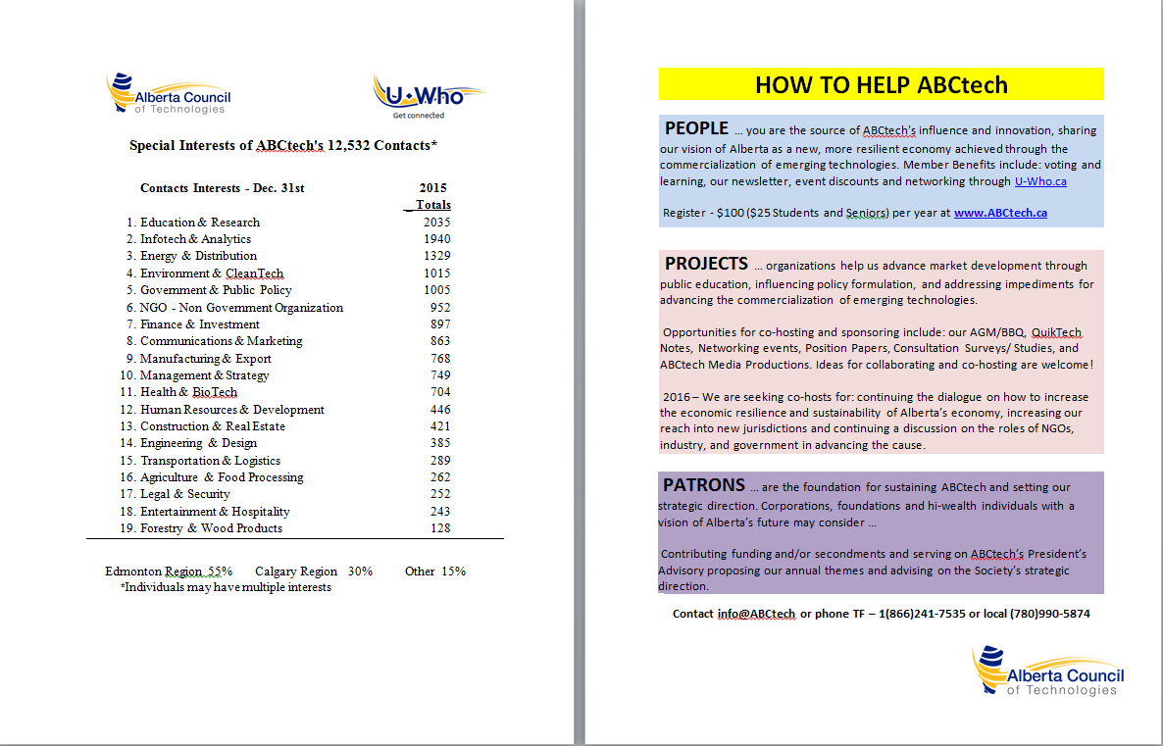
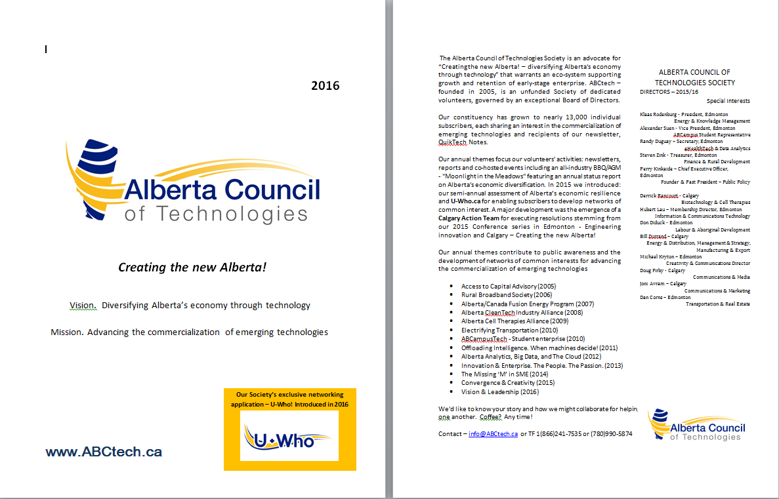

- ABCtech Media Productions – “The Next Question”
Owner of “The Next Question” and all rights to the associated episodes.

 |  | 
“The Next Question” is a radio Program produced by ABCtech Media Productions – a wholly owned subsidiary of the Alberta Council of Technologies Society, for distribution throughout Alberta and across the United States through public radio. The Program’s objectives are public education and to promote Alberta’s interests in innovation.

The Program – test launched in May 2014, is comprised of four series, each with several 2-minute episodes featuring insights about emerging – potentially disruptive, technologies:

CURRENT SERIES |  | For listening Click below
 | MEDICINE & HEALTH CARE |  | Genomics & Cell Therapies
 | INFOTECH & ANALYTICS |  | Privacy & Data Analytics
 | ENERGY & ENVIRONMENT |  | Fusion Energy
 | AUTONOMOUS TRANSPORTATION |  | Levitated Transportation

Budget
The Alberta Council of Technologies Society will provide overall project management including: responsibility for administration of the contractor budgets, resourcing of teams, on-time and on-budget delivery. Plus alignment of messaging in keeping with the terms of the project - $10,000. Existing episodes are owned and released for usage from ABCtech Media Productions $5,537. Budget – $15,537

Potential Episodes:
1. "Rising to the Challenge, Creative But Disruptive Technologies." A glimpse of Alberta's technologies with the potential to mess up everything.
2. “Off-loading Intelligence. When Machines Decide." When computers and apps can serve as aides for automating decision making. What will this mean for smart firms and the professions?
3. "M&Ms - Success is More Than Money!" A probing review of the ingredients to success for new ideas, new starts and innovation.
4. "Knowledge without Relationships, has No Value!" A panel selected to discuss research policies and priorities, the power of networking and what's impeding commercialization.
5. "Personalized Medicine - When?" An investigation of what new technologies - genetic and cell therapies, may mean to healthcare in terms of patient: professional relations, client power and the ethics of life and death.
6. "CleanTech and Alternative Energies." The new found respect for the environment is creating an urgency for innovation: wind and solar, biofuels and hydrogen, fission and fusion.
7. "Managing Change - Discovery and Timing." A frank assessment of the barriers to change and innovation for resolving some of mankind's' greatest problems. The role of management and money.
8. "When Is Enough Enough?" Objectives and prioritizing research? Will it ever to be commercialized? What are the barriers and what role government? Lessons learned here and elsewhere.
9. "Is Rural Alberta Sustainable?" A frank look at three communities undergoing a revitalization from Southern, Northern and Central Alberta.
10. "Alberta - Better Than We Know?" The building blocks for incubating Alberta innovation and enterprise are in place. Who are the leaders mobilizing Alberta's human assets? What programs are working, and why the others? Also, a foreign perspective - what others think?

Michael Flood Writing Services / michael@michael-flood.com / www.michael-flood.com / (780) 983-8410. Writer and editor based in Edmonton. With 5 years of experience as a copywriter, technical writer, and editorialist, he specializes in helping businesses and organizations communicate complex ideas to diverse audiences. In 2014, he wrote 27 episodes of ABCtech Media Production's The Next Question radio program, profiling innovative and disruptive technologies and the people behind them. Since 2015 he has worked as Communications Manager for BioAlberta, the Alberta Life Sciences Industry Association.

PBX – Market demographics
Based on market research we believe that The Next Question is ideally situated for listeners to American public radio (NPR).
 | US Public Radio Listeners
 | On Air | Podcast
Size (millions) | 26.4/week | 24.7/week
Median Age | 49 | 36
Household Income (2012) | $93,100 | $83,501
% BA, MA, or PhD | 69% | 81%

Key observations:

- Above US average in eco-friendly and health activities – this is an audience that pays attention to scientific and medical research in the news and adjusts their behavior accordingly
- 90% of On-Air and Podcast audience has health insurance – further evidence they take their health seriously and will be interesting in health and wellness related news, particularly as it relates to emerging technologies and the question of whether their health plan will cover new treatments.
- Largest share of Public Radio listenership is for News/Talk/Information programming – 49%

- CKUA Radio Network – Alberta
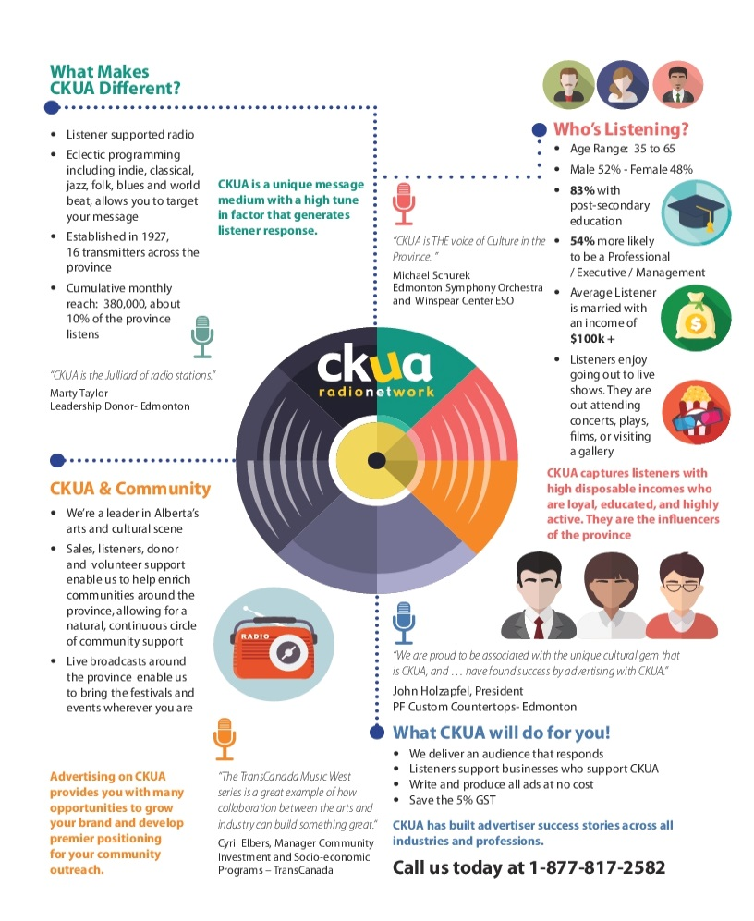 | 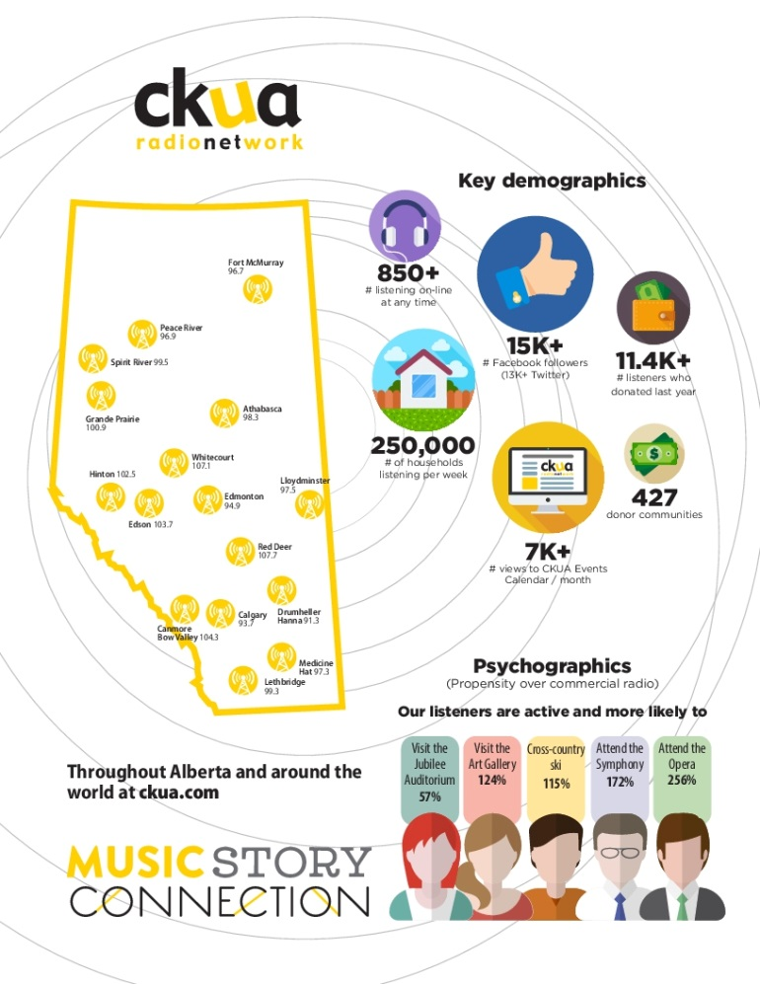
Vision Statement: Music Story Connection
Mission Statement: CKUA is Alberta’s cultural network that celebrates music, engages communities and makes life worth listening.
Broadcast Network: 16 transmitters carry CKUA’s signal on FM radio throughout Alberta. Also available on: Telus Optik’s channel 7046 (Edmonton, Calgary, Grande Prairie, Fort McMurray, Lethbridge, Medicine Hat, Red Deer, Vancouver, Victoria, Campbell River, and Kelowna/Vernon). Shaw Direct (Star Choice) 828 or 492. SaskTel Max TV’s channel 855 (Saskatchewan)
Origins: CKUA began in 1927 with a dream: to take the University to the people via the new medium of radio. With a couple of the University of Alberta’s engineering students, 2 windmill towers, some old iron poles and a little creative book-keeping, a $700 grant was transformed into Canada’s first public broadcaster. The CKUA Radio Network signed on November 21st, 1927, with a 500-watt signal.

CKUA was privatized in 1994, and since 1997 a combination of commercials, corporate sponsorships and listener donations fund the station’s day-to-day operating costs.
CKUA remains steadfast in its commitment to offer listeners the chance to hear Albertan musicians, writers and performers, and to enrich the arts and cultural life of the province. Over 40 programs are featured on CKUA, spanning many music genres and topics. We are proud to continue to offer quality programming for listeners across Alberta and the world.

Over the past 8 decades, CKUA has had the privilege of offering music ranging from classical, jazz, and folk, to blues and world beat. CKUA has shared many firsts with the province of Alberta, including the first Western Canada football play-by-play in 1928, the first Edmonton outlet for a national network broadcast in 1930, and the first station in Alberta with FM Technology. It is with this pioneering spirit that we approach the years and broadcasts yet to come.

Today, CKUA is capable of reaching most Albertans through 16 transmitters across the province. On February 29, 1996, CKUA became the first Canadian station to stream online, giving CKUA a global presence via ckua.com. (now along with huge followings on Twitter and Facebook)

The Next Question - Budget
Pre-Production Labour | Quantity |  | Unit Price |  |  | Cost
Content / Script Writer | 26 |  | $ 250.00 |  |  | $ 6,500.00
Voice Actor (Charged per finished minute) | 26 |  | $ 100.00 |  |  | $ 2,600.00
Industry Consultant 10 $450.00 $4,500.00 | 26 |  | $ 200.00 |  |  | $ 5,200.00
Marketing | 12 |  | $ 200.00 |  |  | $ 2,400.00
Researcher | 26 |  | $ 100.00 |  |  | $ 2,600.00
Administration | 1 |  | $ 1500.00 |  |  | $ 1,500.00
Subtotal |  |  |  |  |  | $ 19,300.00
Production Labour | Quantity |  | Unit Price |  |  | Cost
Content Editor / Senior Producer | 26 |  | $ 150.00 |  |  | $ 3,900.00
Audio Engineer | 26 |  | $ 100.00 |  |  | $ 2,600.00
Studio Bookings | 6 |  | $ 250.00 |  |  | $ 1,500.00
Subtotal $2,400.00 |  |  |  |  |  | $ 8,000.00
Off-Site Labour (Interviews) | Quantity |  | Unit Price |  |  | Cost
Interview fees | 6 |  | $ 250.00 |  |  | $ 1,500.00
Interview Logistics -Travel/ Meals etc. | 6 |  | $ 150.00 |  |  | $ 900.00
Subtotal |  |  |  |  |  | $ 2,400.00
Total before broadcast costs |  |  |  |  |  | $ 29,700.00
Broadcasting | Quantity |  | Unit Price |  |  | Cost
Broadcast Element - CKUA Based on 1 minute segements | 52 |  | $ 144.00 |  |  | $ 7,488.00
( 26 episodes produced - repeated once a year to get 52 weeks - Saving on producing 52
Station Promo + web + Social Media) |  |  |  |  |  | $ 9,200.00
Total Yearly Broadcast costs |  |  |  |  |  | $ 16,688.00
Total yearly costs all in |  |  |  |  |  | $ 46,388.00


- Hybrid Ventures

Corporate Profile
Hybrid Ventures is an Alberta Group of Companies serving global education, information and technology markets, with a mandate to incubate and create solutions that solve real problems for real people around the world while bettering their quality of life, business and/or personal. This portfolio includes:
Hybrid Global Inc., formerly Hybrid Forge, a custom software consultancy that has been in business in Alberta since 2006 and has served the province via the following clients: Alberta Innovation & Advanced Education, Alberta Education, Alberta Transportation, The Alberta Library, The Alberta Legal Information Society and Alberta Blue Cross, just to name a few.
Stacks Inc., a SaaS startup founded in Alberta which is currently distributed globally via a strategic partnership with EBSCO Industries, a privately held American corporation with product in more than 170 countries.
Building the Future, a radio and television show interviewing Startups, Entrepreneurs, Investors, and others helping to make our world a better place; curated, recorded and produced here in Alberta, with broadcasting details noted below.

Podcast, Radio & TV:
- Airing online as a podcast via iTunes, Google Play, AppleCoreMedia, Overcast, Stagefright, Stitcher, Pocket Casts, DoggCatcher, Instacast, Downcast and more.
- Airing live on WDJY 99.1 FM http://www.wdjyfm.com/ in Atlanta Tuesday's & Thursday's at 2pm EST, Every night at 1am PST on The 405 Media http://the405media.com/
- CCTV Public Content (Time Warner 21/Cincinnati Bell 811) in Kentucky Tuesdays at 7:30am, Thursdays at 9:30pm, and Saturdays at 3:30pm http://campbellmedia.org/
- Each episode of the show receives over 11,000 listens in Atlanta and online and has been heard in more than 90 countries this year.
- We are in the process of airing the radio show in New Mexico and other states in early 2017
Building the Future Show is hosted by Kevin Horek, Partner, Hybrid Ventures.

Kevin is a thought leader, a journalist and a published author with a remarkable reach.
- Published author Learning Zurb Foundation book by Packt Publishing
- TechZulu.com columnist - readership is 20,000 - 30,000 monthly

Combined Social Media Reach
- Social media reach across all the major networks, via all our channels was over 900,000 for the month of October, 2016 alone.

Budget – Hybrid Ventures | Annual Cost
Hybrid’s Production – Incorporating “The Next Question” – produced by CKUA into “Building the Future Programming (USA) – est. 100 episodes | $ 4,875.00
Marketing – “The Next Question” – Social media channels – est. 6 such as Facebook, Twitter, etc.) – est. 100 episodes | $ 1,200.00
Before and After posts per episode – est. 100 episodes | $ 2,000.00
Total yearly costs | $ 8,075.00



- Centre for Global Education

Alberta is entering a time where it is redefining its place in the world. Despite a strong heritage of science, technology and the arts, many Albertans have traditionally defined themselves as an “Energy Industry” province. In the midst of significant challenges to this paradigm, we are entering a strategic time of engagement for Albertans around the re-envisioning of their province.

The Centre for Global Education – our mission is to educate 21st Century students for a 21st Century world by providing global learning opportunities, enhanced through technology, informed by sound research and innovative teaching. Through a series of strategic relationships, The Centre has uniquely placed itself as a international hub of technology innovation, higher learning and global education.

Since 2007, over 500,000 students, from over 600 schools, in 35 different countries have participated in thousands of conferences, making it the largest provider of real-time high school real-time collaborative programming in Canada and amongst the largest in the world. From UNESCO to the RCMP, Child Soldiers to Climate Change, the Centre works with over 25 different government, industry and non-government organizations to connect the world’s youth through three major programs:

Campus Connect - opens the world of higher learning to Alberta students. From the University of Alberta to the Research Council of Canada, from Alberta School of Art to Beijing University, these one hour sessions, take high school students into the very heart of higher learning, opening their eyes to the world of potential available through academic.
Global Encounters - bring together students from across the world through live video conferences that explore global issues and the potential youth have to shape a better common future. Each interdisciplinary, project-based Encounter has a specially designed TIG Virtual Classroom, to foster asynchronous student collaboration. Furthermore, a team of global expert mentors is recruited for each session, to provide students with authentic and timely feedback on their online postings.
Virtual Town Hall/White Papers – act as the culminating event at the end of one to three months of online collaboration between youth around a critical local, national or international issue. The entire extended process effectively synthesize the voice of thousands of young people through the use of social media and other online technologies used to share ideas and communicate. Whether youth are connected across the province or around the world, the process is designed to help youth wrestle with complex global issues, in a collaborative online space, led through a dialogue with local and international experts. In the end, students create a unified document, synthesizing the voice of the represented youth. Engaging from 500 to 10,000 students, these document have been presented all around the world, from the United Nations Climate Change Conference to the Premier of Alberta.

Engaging Students – Virtual Town Hall and White Paper

The Long-term Project Goal is to enable young people to learn about and engage with their communities, local and provincially, in the creation of a vision for change in education, society around the role technology, science and the arts.

The Short-term Project Goal is to link thousands of students across Alberta to collaborate and write a white paper sharing their vision for the future of Education with a special focus on Technology, Science and the Arts.

The Project’s two interconnected streams:

- Six to eight schools collaborate to prepare a white paper on their vision for the future of
Education in Alberta (January 2017 – April 2017).
- Create curriculum for engagement (October – December 2017)
- Six to eight provincial lead schools (six municipalities) from across Alberta are selected to participate.(January 2017)
- Over the course of six weeks, student leaders from each of the provincial lead schools (30-40 student leaders) meet on a weekly basis to research and identify key issues (working both synchronously, via video conferencing, and asynchronously, using a specially designed interactive student portal, discussion boards, blogs, etc.). (February 2017-March 2017)
- Provincial lead schools meet in a province wide virtual town hall to facilitate a larger group discussion (200-300 students). Various local and provincial stakeholders are invited to join. (March 2017)
- Creation of a survey based on the results of the above collaborations, validated by a larger community of students (1000-2000 students). (March 2017)
- A select group of student leaders (12-16 students, 2 from each school) come together at the University of Alberta to synthesize the work done into a paper. (March 2017)
- This paper would be presented on behalf of the youth of Alberta to ABC tech with the option of sharing it to other strategic stakeholders (i.e. Minister of Education, local school boards, local Chambers of Commerce, etc.) (April 2017 – ongoing)

2. Other Schools Investigate Critical Issues in their Community – March-April 2017 (Stream 2)
Students in other provincial schools, examine and communicate on key educational change and social issues in their communities using social media. Their contributions are integrated into the main stream of dialogue in Stream 1. CGE and ABC Tech will promote this Stream 2 activity through their websites, social media and networks.
Project Metrics

The students from the provincial lead schools will produce a position paper. This paper may be presented through a workshop for education leaders at a provincial education technology conference.

Estimated student engagement includes:
Stream 1 Students. 6-8 lead schools from across Alberta,
    - 30-60 leadership students;
    - 100-200 students in Virtual Town Hall
    - 1000-2000 student from the general student body participate in survey
Students from other local schools may participate in the Education Technology Conference workshop.
Stream 2 Students. 20 classes and/or leadership groups participate, or approximately 500 students

Other Potential Partners

- Alberta Teachers Association | - Community Groups
- ATA Teacher Specialty Councils | - Chambers of Commerce
- Education Technology Organizations | - School Boards
- Technology industry leaders | - Arts Organizations
- Post-secondary institutions

Budget – Engaging Students

Develop resources for provincial lead schools process and work | $ 3,000
Technology and Technical support for online process and video conference  [CGE provides videoconference at no-charge, valued at $3,000] | 500
Train and support students in working in online process and facilitate videoconference | 4,500
Technology and Technical support for Stream 2 Students | 500
Promotion and support to Stream 2 Students | 500
With ABC Tech, evaluate short-term project and evaluate engagement design for a long-term youth engagement program | 1,000
Administration (10% of above) | 1,000
Preliminary total | $ 11,000
TIG and CGE donation in Kind | 1,000
Final Total | $ 10,000

- Creating the New Alberta – Vision & leadership CONVENTION

Attracting Big Ideas - The Time is NOW!


What technologies can help revitalize Alberta's economy?
A Convention like none other …. most timely for inspiring initiative and the convergence of BIG IDEAS by Alberta’s industries and professions contributing to economic recovery and long-term diversification. Share yours. What Can be done. What is being done. The time is Now for Innovation. Convention features:

KEYNOTES - Insightful and inspiring Opening, Luncheon, and Closing
BIG IDEAS - Presented by Alberta industries and professions
RECOGNITION - ABCtech’s 2nd Annual Innovation Award and top 3 BIG IDEA presentations
CONVERGENCE - Panels with Q&A presenting VERY BIG IDEAS for expediting change
ACTION - An engaging Plenary session for Setting Direction and Taking Action
CONNECTING – Wrap-up Networking Reception. Meeting Alberta leaders and visionaries.
Date, time and  location | Saturday, November 26th  9:00am to 6:00 pm  Cenovus Learning Centre at Red Deer College MAP HERE
Overview
Planning is well underway. Industry keynotes are secured. Industries and professions are
assembling brief PPT presentations of BIG IDEAS for this electrifying Convention. You’ll be at
the sharing of BIG IDEAS and the birthing VERY BIG IDEAS for aiding Alberta's economic
recovery and long-term diversification. Bring yours - audience engagement is a prime
expectation.

15
SCHEDULE
8:00 am Registration Desk opens – badges and program handout
9:00 am Opening Keynote | Kim Campbell re "Vision & Leadership"
9:30 am Big idea Attendees will have 3 votes for choosing the top 3 BIG IDEAS
Presentations contributing to Alberta’s economic recovery and long-term
diversification from among several PPT presentations by Alberta
industries and professions:
Agriculture & Food Processing Forestry & Wood Products
Transportation & Logistics Construction & Real Estate
Health & BioTech Volunteers & NGOs
Fintech & Investments Mining & Mineral Processing
BREAK
Tourism & Entertainment Communications & Marketing
InfoTech & Analytics Manufacturing & Export
Environment & CleanTech Alternative Energies
BREAK
Engineering & Design Education & Creativity
Legal & Security Management & Strategy
Human Resources & Development Finance & Accounting
12:30 Luncheon  Keynote & Recognition | Buffet Luncheon  Donna Kennedy-Glans re "Energy Transitions"  Announcing and awarding the top 3 BIG IDEA presentations  Presentation of ABCtech's 2nd Annual Innovation Award
2:00 pm Convergence  Panels and Q&A | Three panels portraying VERY BIG IDEAS, selected for expediting change. The convergence of opportunities with an audience Q&A
3:30 pm Plenary Session | Roundtable discussions for deriving recommendations, concluding with an overview for setting direction and taking action
4:45 pm Networking  Reception | Sumptuous networking reception. Meeting Alberta's leaders and visionaries.
6:00 pm Closing | Perry Kinkaide re "Growing Together" Thank you and Good night!

- Alberta’s Economic Resilience Survey Reports – Visit
http://www.abctech.ca/economic-resilience-surveys?mid=1307

- Report – “Why SMEs Fail to Grow” – Visit
http://www.abctech.ca/uploads/files/Management_and_Strategy/Report%20-%20Why%20SMEs%20Fail%20to%20Grow.pdf

16
- Letters of Support


To Whom It May Concern:

October 27, 2016

The Alberta Council of Technologies Society has for some time envisioned the development of a broadcasting network and program dedicated to educating the public about Alberta enterprise, innovation and innovators.

We are very proud to introduce Alberta Innovates to the partners who have stepped forward to help launch this project: ABCtech Media Productions supplying existing content, The Centre for Global Education for engaging Alberta youth, CKUA to help in producing and broadcasting The Next Question adding additional content, and Hybrid System with its established webcasting experience and extended reach into the United States.

Sincerely,

Klaas Rodenburg,
President, Alberta Council of Technologies Society

17

To who it may concern,

October 27th, 2016

The mission of the Centre for Global Education is to educate 21st Century students for a 21st Century world by providing global learning opportunities, enhanced through technology, informed by sound research and innovative teaching. We are proud to partner with the Alberta Council of Technologies in the development of a network for helping Alberta students and the public envision the future of Alberta, specifically it’s system of education.

Sincerely,

Terry Godwaldt, Executive Director
The Centre for Global Education

18

October 27, 2016

To Whom It May Concern,

Hybrid Ventures and Building the Future Show are pleased and proud to be working with the Alberta Council of Technologies on delivering Alberta innovation and enterprise stories to Albertans and the world.

We are committed to creating global awareness of Alberta’s enterprise, innovation and innovators and facilitating strong partnerships for impactful and meaningful outcomes.

Sincerely,

Kristin Delwo
Principal, Hybrid Ventures



To Whom It May Concern:

October 27, 2016

The CKUA Radio Network is pleased and proud to be working with the Alberta Council of Technologies on promotion and education around the Alberta push for diversification and stepping into the new Knowledge based economic future that is to come!

We believe this comes at a time where Alberta really needs to hear the success stories that exist right here in our own backyard.

The proposed project should help create awareness and understanding for the public, while promoting forward thinking and strategic planning.

Respectfully

Don Barnes
Manager, CKUA Radio

