PROGRAM    3:30 Registration Desk Opens  4:00-7:30 Food Stations and Beverage Truck Open  4:00-4:30 Entertainment Centre I – Classical Piano Stylings by Tiffany Mellor  4:13 Main Pavilion – R-ne as MC welcomes audience  Main Pavilion - Introducing Terry Godwaldt & Haley Simons  4:18-4:30 "Engaging Youth - Creating the New Economy"  4:30 Greetings Alberta Advanced Education – Minister Marlin Schmidt  4:30-5:10 Flower Garden Auction I  4:45 Main Pavilion - Introducing Jesse Hahn  4:48-5:00 "Creating Western Canada's Hemp Industry"  5:00-5:30 Entertainment Centre II - Caylie Ganam - Singer/Songwriter  5:15 Main Pavillion – Introducing Klaas Rodenburg  5:18-5:30 "Going Global"  5:30 Greetings Edmonton Global – Malcolm Bruce  5:45 Main Pavilion – Introducing Don Diduck & Robert McGarvey  5:48-6:00 "TechInvest – Alberta’s New Technology Investment Fund"  6:00-6:30 Entertainment Centre III - Dance Feature - Kalyna Howell-Matwichuck  6:15 Main Pavilion – Introducing Perry Kinkaide  6:18-6:30 "A Sober Assessment of Innovation"  6:30-7:10 Flower Auction Centre II  6:45 Main Pavilion – Introducing Randy Duguay  6:48-7:00 ”How Technology is Personalizing Healthcare"  7:00-7:30 Entertainment Centre IV - 'Rose Protocol' - Indie Rock Band  7:15 Main Pavilion – Introducing Paul Godsmark  7:18-7:30 “BIG Ideas for Automating Transportation"  7:30-8:10 Flower Auction Centre III  7:45 Main Pavilion – Introducing Leigh Bond  7:48-8:00 “Financing Clean Energy with PACE"  8:15 Main Pavilion  Thank you and join us! - Sharon MacLean  After-party - Mahogany Bar in the Selkirk Hotel, Fort Edmonton  8:31 Sunset 9:43 Full “Sturgeon” Moonrise |   Location – in the showgrounds just off Fox Drive, Edmonton  REGISTER AT ABCtech.ca  General Admission $50. Students/Seniors $30.  Member discounts 20% apply.  Main Pavilion – Emerging Technologies  Alberta Council of Technologies  Technology is changing everything, everywhere, and fast!  Entertainment - Creativity Centre  Alberta Creativity Network  Creating the new economy - a blending of arts and science  Flower Garden Auction  Edmonton Horticultural Society  A horticultural splash of colour, imagination and creativity!  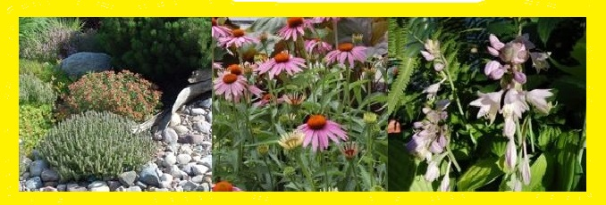  Not to be missed … as the summer winds down, come see and take home for someone special rich memories of the summer. Donated by the renown suppliers supporting this Region’s growing reputation as a horticultural centre. Proceeds are being donated to our “Engaging Youth – the future of work” project.  Charitable tax donation’s apply.
HOSPITALITY/EXHIBITOR SUITES
REGISTRATION. Alberta Council of Technologies Society & GO Mentor
E – ENTERTAINMENT. Alberta Creativity Network
M – MAIN PAVILLION. Alberta Council of Technologies Society, Just Chillin, Honest Dumplings
A – FLOWER GARDEN AUCTION. Edmonton Horticultural Society, Vicrom, Tapa VINO
1 – Technology Alberta, Alberta CleanTech Industry Alliance, nanocluster Alberta, BioAlberta
2 – Clean Energy Technology Centre, PACE Alberta, Clark Ecoscience, Graphene Canada
3 – EDMONTON INTERNATIONAL AIRPORT
4 – Royal Bank of Canada, Miller Thomson, Intercon Messaging, TEC Edmonton
5 – Advanced Technology Centre, Whitemud Equine Learning Centre, Fort Edmonton Foundation

SUPPLIERS
Horticulture | AV Services | R-ne as MC | Entertainment | Event Management
 |  |  |  | 
Volunteers | Auctioneer | Call Centre | Power | Showgrounds
 |  |  |  | 
Marketing | Food | Beverages | Event Supplies | After Party
 |  |  |  | 
Marketing | Marketing | Marketing | Marketing | Marketing - Websites
 |  |  |  | 

