The dark vision of America

Persecuting groups of people to score political points is not OK.
Noah Smith

Sep 19


I’m sorry, I know I already wrote about this last week. But I just can’t let this one go. If I’m repeating myself, I’m sorry, but this is very important.
It’s easy to let the latest outrage slip by as the news cycle turns. Just two weeks ago, Tucker Carlson glowingly recommended a Hitler apologist. Just one week ago, a company that sponsors a bunch of major right-wing podcasters was indicted for working for the Russian government. In past eras these might have been scandals that consumed the nation for months; now they don’t even last one week.
And yet the “Haitians eating pets” thing seems to be sticking around for a bit. I find myself coming back to it again and again — not just because it’s such a moral outrage, but because it so starkly illustrates the divergence between the vision of America espoused by the Trump movement and the vision I was raised to believe in. Like Russia’s invasion of Ukraine, it’s one of those rare moments of complete moral clarity. Yet even something this obvious still needs to be articulated.
For those who don’t already know, the story goes like this. Just before the presidential debate on September 10, Trump’s vice presidential candidate JD Vance began to amplify rumors that Haitian immigrants were abducting and eating pets in the small Ohio city of Springfield. Trump picked up this rumor and claimed it as fact on the debate stage, declaring:
What they have done to our country by allowing these millions and millions of people to come into our country. And look at what's happening to the towns all over the United States. And a lot of towns don't want to talk — not going to be Aurora or Springfield. A lot of towns don't want to talk about it because they're so embarrassed by it. In Springfield, they're eating the dogs. The people that came in. They're eating the cats. They're eating — they're eating the pets of the people that live there. And this is what's happening in our country.
After the debate, both Trump and Vance doubled down on the claim that the Haitian immigrants of Springfield were abducting and eating pets. But the story had already begun to fall apart.

The “Haitians eating pets” story was completely and utterly fake
I’m not throwing around the word “fake” lightly here. What I mean is that the story about Haitians eating pets was a combination of deliberate fabrication and completely baseless stereotype-driven panic. Vance, in particular, appears to have deliberately amplified rumors that he knew were very likely false.
When journalists started asking police and local government officials in Springfield about the pet-eating rumors, they found no such incidents. JD Vance, pressed to back up his claims, cited a police report by a woman who claimed that her cat had mysteriously vanished and might have been abducted by her Haitian neighbors. The cat was found in the basement shortly thereafter:
A Vance spokesperson on Tuesday provided The Wall Street Journal with a police report in which a resident had claimed her pet might have been taken by Haitian neighbors. But when a reporter went to Anna Kilgore’s house Tuesday evening, she said her cat Miss Sassy, which went missing in late August, had actually returned a few days later—found safe in her own basement.
Kilgore, wearing a Trump shirt and hat, said she apologized to her Haitian neighbors with the help of her daughter and a mobile-phone translation app.
Another Springfield woman, who had posted rumors about pet-eating Haitians to a Facebook group, later apologized and admitted that she had no evidence:
The woman behind an early Facebook post spreading a…claim about Haitian immigrants eating local pets…says she had no firsthand knowledge of any such incident and is now filled with regret and fear as a result of the ensuing fallout.
“It just exploded into something I didn’t mean to happen,” Erika Lee, a Springfield resident, told NBC News on Friday.
Desperate to find any sort of substance to back up the pet-eating claim, online rightists posted an image of a black man walking down the street holding two dead geese. It turned out that the man — who isn’t Haitian and lives in Columbus — was just moving roadkill off of the road. Chris Rufo, the right-wing activist, offered $5000 for any proof of Haitians eating pets, and came up with a blurry video of African immigrants in Dayton, Ohio grilling carcasses of unknown origin. Independent right-wing journalists swarmed the area, looking for evidence of pet-eating, and found nothing.
Some onlookers also pointed out that the sudden hysteria about Haitians in Ohio was extremely suspicious, since the vast majority of Haitian immigrants in the U.S. live in Florida or the East Coast:
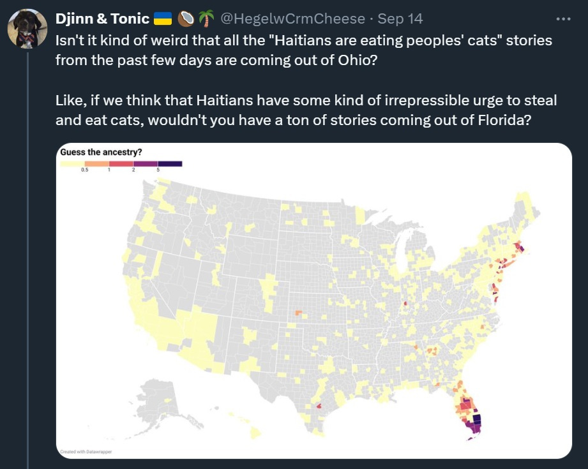
The pet-eating story, in other words, was fake. And there are indications that JD Vance, at least, knew that it was fake. The Wall Street Journal reports that Vance kept repeating the accusation long after his staffers had been told that there was no evidence of pet-eating:
[Springfield] City Manager Bryan Heck fielded an unusual question at City Hall on the morning of Sept. 9, from a staff member of Republican vice presidential nominee JD Vance. The staffer called to ask if there was any truth to bizarre rumors about Haitian immigrants and pets in Springfield.
“He asked point-blank, ‘Are the rumors true of pets being taken and eaten?’” recalled Heck. “I told him no. There was no verifiable evidence or reports to show this was true. I told them these claims were baseless.”
By then, Vance had already posted about the rumors to his 1.9 million followers on X. Yet he kept the post up, and repeated an even more insistent version of the claim the next morning.
And in an interview with CNN’s Dana Bash, Vance indicated that he knew he was amplifying unsubstantiated rumors for political purposes, saying “If I have to create stories so that the American media actually pays attention to the suffering of the American people, then that’s what I’m going to do.”
It’s not clear whether Vance was admitting to having deliberately fabricated a story. But he has made it clear that he’s sometimes willing to speak falsehoods in order to make a political point. When a reporter pointed out that most of the Haitians in Springfield are in the country legally, under a Congressionally approved program called Temporary Protected Status, Vance declared: “I’m still going to call them an illegal alien.”
In fact, the pet-eating accusation might not turn out to be the only piece of the Trump campaign’s story that doesn’t fit the facts. Trump supporters constantly claim that 20,000 Haitians have recently come to Springfield. But the city of Springfield estimates that there are only 12,000 to 15,000 total immigrants of all nationalities in the entire county. The 20,000 number isn’t just exaggerated in size — it also conflates recent arrivals with immigrants who have been there a long time, and it labels immigrants of all nationalities as Haitians.
In fact, when people started digging into the data, they realized that the number of Haitians in Springfield is much, much smaller than popularly claimed. Census Data shows a decrease in the county’s black population since 2019, an increase in the “West Indian” population of only about 1100, and an increase in the total foreign-born population of only about 2200. School enrollment is flat, the number of people receiving welfare benefits is flat, employment has barely risen, and so on. Using Medicaid data and data on enrollment in ESL classes, David Jarman estimates a total immigrant population of about 10,000 in the country. But Kevin Drum argues that many of these are not Haitians, and comes up with an estimate of about 4,000.
And other anti-immigrant claims have turned out to be baseless as well:
Vance has also added to his claims about Haitians, saying on social media that communicable diseases have been on the rise in Springfield because of the Haitian migration…Information from the county health department, however, shows a decrease in infectious disease cases countywide, with 1,370 reported in 2023—the lowest since 2015.
In other words, the whole framing and background narrative of the Haitian immigrant panic looks wrong.
It’s highly likely that Trump, Vance, and many of their most prominent supporters know they have these particular facts wrong. And yet because they’re angry about immigration in general, and because they see it as a winning electoral issue, they’re willing to throw a whole bunch of accusations at the wall and see what sticks.
It’s difficult to express how immoral this feels. Throwing around talking points and dubious data is one thing. But if you’re leveling baseless accusations against specific innocent people in order to make a broader political point, you’re hurting those people for your own political gain. There is simply no situation in which I find that morally acceptable.
But the singling out and persecution of undesirable groups for political gain fits perfectly with Trump’s vision of what a nation ought to be.

A battle between two visions of America
Make no mistake: The Haitians of Springfield have been harmed by the baseless calumnies the Trump campaign has leveled against them. So have their non-Haitian neighbors. The Wall Street Journal reports that the town has been under siege since Trump blasted his baseless rumors to the world:
The Ohio state police were called in to protect local children as they returned to school. A security tower with cameras was erected outside City Hall. Thirty-six bomb threats had been logged [in Springfield] as of Tuesday evening.
“It induces panic and fear and depletes resources,” said Heck, the city manager. “We’re living the danger that misinformation and created stories leads to.”…
The morning after the debate, parents in Springfield kept their children home en masse. Several schools, City Hall and the state motor vehicle offices in Springfield were forced to evacuate after receiving bomb threats. The city canceled its two-day CultureFest celebrating diversity, arts and culture “in light of recent threats and safety concerns.”
[Neo-Nazi group] Blood Tribe took a victory lap for its presence in the town, boasting on Sept. 11, “We are on the ground in Springfield weekly—we even showed up to their City Council Meeting.”
Health care facilities and city hall were also evacuated due to bomb threats. Most or all of those threats are believed to have come from out of town — or out of the country.¹
Imagine that you’re a Haitian guy living in Springfield. You fled one of the world’s most dangerous and violent countries for the chance at a good life in the United States. You came legally, through a program established by Congress. You go to work at the steel factory, and you show up on time and you do your work and you don’t do drugs. On Sunday you go to church. You’re making it in America. You’re following all the rules, and you’re doing right by your country and your family.
Then one day America’s presidential front-runner says that you’re abducting and eating people’s pets. Suddenly your daughter is getting evacuated from school day after day because of bomb threats. You wonder if your neighbors believe Trump’s lies. People ask your daughter what cat tastes like.
What did you do to deserve any of that? Nothing. Nothing except be born to a group of people that Trump and his supporters think doesn’t deserve to be part of America. Nothing except have the bad luck to be in the line of fire when Trump thought he could win votes by stirring up hatred and fear. There’s nothing you could have possibly done to avoid it — you did everything right, and they still came after you.
That is not the America you were promised. And it’s not the America I was promised, when I grew up hearing Ronald Reagan say things like:
[A]nyone, from any corner of the Earth, can come to live in America and become an American…This, I believe, is one of the most important sources of America's greatness. We lead the world because, unique among nations, we draw our people—our strength-from every country and every corner of the world. And by doing so we continuously renew and enrich our nation. While other countries cling to the stale past, here in America we breathe life into dreams. We create the future, and the world follows us into tomorrow. Thanks to each wave of new arrivals to this land of opportunity, we're a nation forever young, forever bursting with energy and new ideas, and always on the cutting edge, always leading the world to the next frontier. This quality is vital to our future as a nation. If we ever closed the door to new Americans, our leadership in the world would soon be lost.
And yes, Reagan included Haitians in that list. This is from his Republican convention acceptance speech in 1980:
Can we doubt that only a Divine Providence placed this land, this island of freedom, here as a refuge for all those people in the world who yearn to breathe free? Jews and Christians enduring persecution behind the Iron Curtain; the boat people of Southeast Asia, Cuba, and of Haiti; the victims of drought and famine in Africa, the freedom fighters of Afghanistan, and our own countrymen held in savage captivity.
That America is not gone. In fact, it rose up to defend the Haitian community of Springfield after Trump’s attacks. Springfield residents have reportedly flooded into Haitian-owned restaurants in a show of support. A Springfield church sent flyers to Haitians reading “I’m glad you’re here. Jesus loves you and so do I.” There was a peaceful protest in support of the Haitian community. Mike DeWine, Ohio’s Republican governor, denounced Trump’s baseless rumors as “garbage” and condemned the neo-Nazi groups that have come to march in the town.
Although 52% of Trump supporters said they either “definitely” or “probably believed Trump’s accusations of pet-eating, the majority of Americans, including a majority of political Independents, said the accusation was false.
Yet this is not an overwhelming majority. The Trumpian vision of America is a powerful alternative to Reagan’s vision. Trump and his supporters see a nation as defined not by ideals, but by ethnocultural inheritance. Immigration, to them, is not an affirmation of America — it’s an invasion, a pollution of the national bloodstream, an attempted theft of the country from its rightful owners. It’s an alternative idea that has been in America since its founding, but has only rarely gained political power.
It could definitely gain power this time, though. Thanks to Biden’s neglect of the border crisis for the first three years of his presidency, American opinion swung from a pro-immigration stance in 2020 to an anti-immigration stance in 2024. Biden belatedly acted to shut down the border by barring most asylum claims, and illegal border crossings have plummeted as a result. But this turnabout came too late, and now an enraged country is in danger of embracing Trumpian ethnonationalism as its only alternative
Perhaps Trump’s attack on the Haitians of Springfield will change that dynamic. Americans may despise illegal immigration, but they continue to think well of immigration overall:
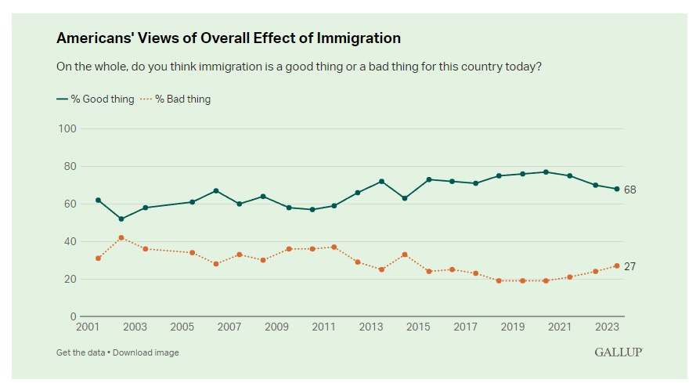
Source: Gallup
By singling out the Haitians of Springfield for attack, Trump may have given immigration a human face again — replaced the mental image of an army of faceless invaders storming across the border with the image of a hard-working minority trying to fit in and make it in America. This may have been a tactical error. Trump and Vance might have been too confident that their blood-and-soil vision of America was finally in the ascendance — that in Haitians, they had finally found a group of people that the nation would categorically reject as unworthy and unacceptable. Instead, they may simply end up reminding Americans of Reagan’s vision, and of their own immigrant roots.
I don’t think it’s settled yet. The election is still a tossup, and anger about the border is still at a fever pitch. Canada and many European countries are moving toward greater immigration restriction. Even if Harris wins, she’s likely to keep Biden’s strict border measures in place. Every country has its limit when it comes to uncontrolled immigration, and America has reached the end of its tolerance in that regard.
But Trump’s lies about the Haitians of Springfield have given America a glimpse of the dark vision that lies beneath the populist anger. Americans now know that Trumpism doesn’t just mean a secure border — it means a country where people can be persecuted purely for their membership in an undesirable group. Some Americans do want that. If you want that, vote for Trump. But it’s not a vision of the country we grew up in, and it’s a not a vision that leads anywhere good.

