**Technology & Engineering - Changing everything ... fast (11JUN23)**

**AI Prompting Anxiety.** Computers have an ever increasing capacity to process data. Data production and data access are also limitless.  Now with generative AI on the loose artificial humans may possess super intelligence partnering and possibly replacing people in the workforce. The opportunities appear limitless. [**HERE**](https://www.mckinsey.com/featured-insights/mckinsey-guide-to-problem-solving/can-ai-help-you-solve-problems)While AI is expected to boost innovation, productivity and global GDP, disruptions need to be anticipated and managed. [**HERE**](https://www.brookings.edu/research/machines-of-mind-the-case-for-an-ai-powered-productivity-boom/)AI are apps are getting very creative. [**HERE**](https://intelligence.weforum.org/topics/a1Gb0000002V7TyEAK/publications/423a19bb836543229e389acc47fa4a96) **S**hould AI be used to create jobs?[**HERE**](https://www.noahpinion.blog/p/why-trying-to-shape-ai-innovation?utm_source=substack&utm_medium=email)Can regulators keep up? [**HERE**](pnews.com/article/artificial-intelligence-ai-consumer-finance-rules-8f5a450bd05e6079c742a9ce00b5c576?utm_medium=auto.techbriefing.us.fri.rd.20230526&utm_source=email&utm_content=article&utm_campaign=email-2022)  Founders think they should.[**HERE**](https://kadence.com/ai-in-market-research-hope-or-anxiety/)

**Achieving Decarbonization.** Climate plans are recognizing hydrocarbons as required to effect an orderly transition to low carbon, net zero emissions energy systems. [**HERE**](uploads/files/Documents/FINAL%20DRAFT%20-%20Canadians%20are%20being%20misled.docx)Emerging countries are the big emitters and need energy now.[**HERE**](https://www.brookings.edu/blog/future-development/2023/04/13/building-a-prosperous-world-with-fewer-emissions/)

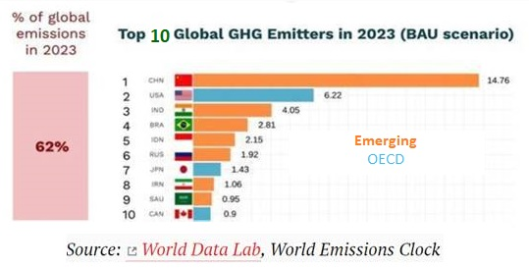

**Embracing Nuclear Energy.** Since the advent of the atomic age, public angst about nuclear waste, runaway fission, and weaponization have empowered regulators to contain nuclear as a source of energy. But, over time treaties and technology, an improved safety record and the ever-growing demand for decarbonization, have served to renew the acceptance of nuclear as an energy source.  [**HERE**](https://www.imf.org/en/Publications/fandd/issues/2022/12/nuclear-resurgence-nordhaus-lloyd)  Nuclear going small and mobile with SMRs 1% the size of conventional plants**.** [**HERE**](https://www.japantimes.co.jp/news/2023/05/23/business/pentagon-next-generation-nuclear-reactors/)Also relevant is continued progress in replicating the sun on earth - fusion, as a future nuclear energy source**.**[**HERE**](https://www.scientificamerican.com/article/what-is-the-future-of-fusion-energy/)

**Pursuing Everlasting Life.** When asked, most people say that they would not opt for everlasting life.  Regardless researchers continue to explore anti-aging technologies for extending life - possibly without end. [**HERE**](https://interestingengineering.com/health/this-is-why-we-are-aging)and[**HERE**](https://www.frontiersin.org/articles/10.3389/fragi.2023.1148926/full)